***Unit2***

**Mates Andrei Aurelian**

**Exercitiul 1**

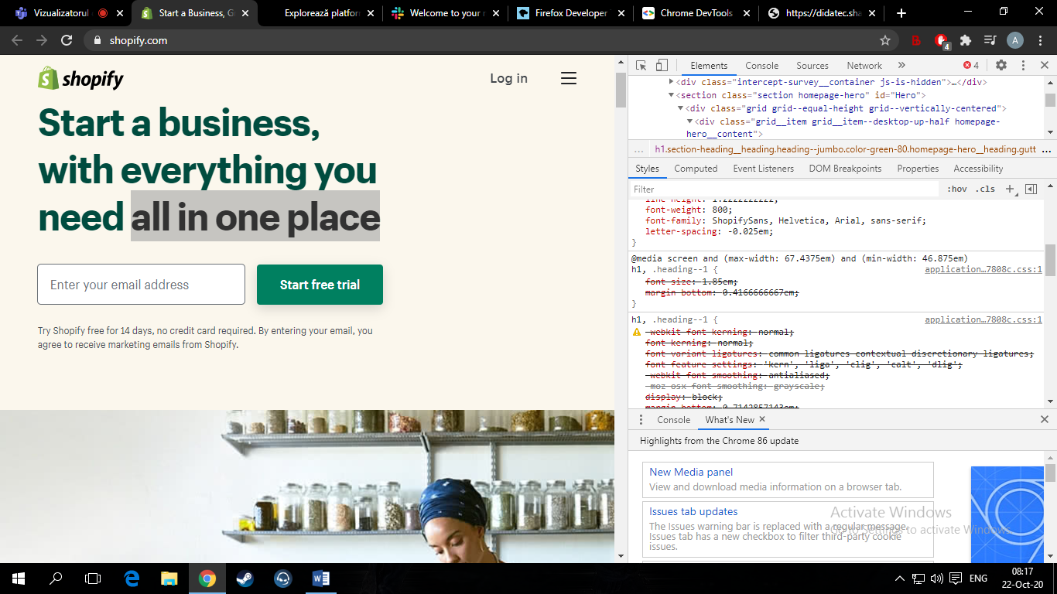

**Font:1,85**

**Display:block**

**Letter spacing:0,02071**

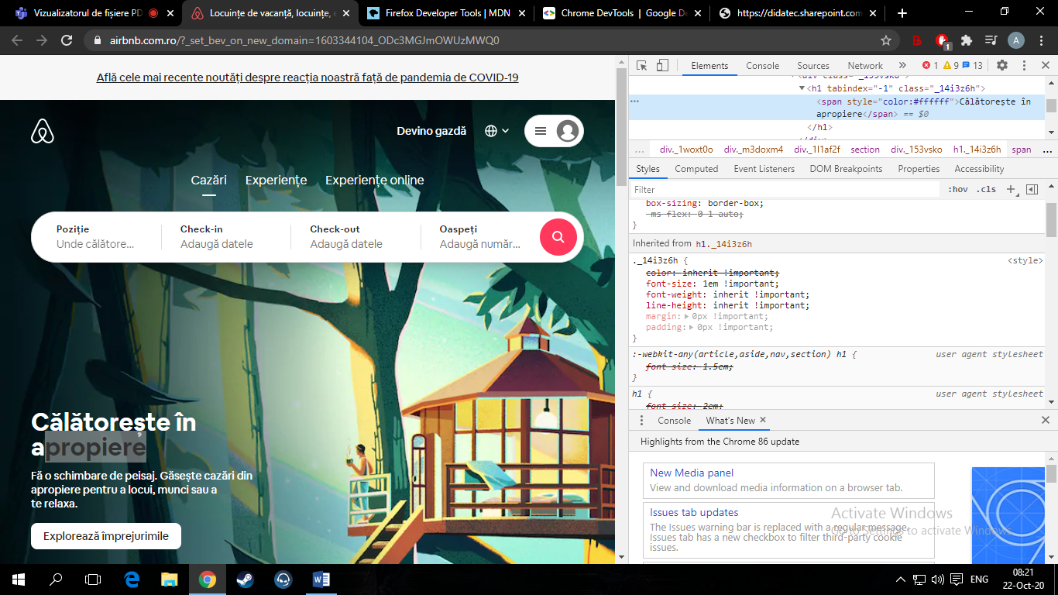

|  |  |
| --- | --- |
| **shopify** | **airbnb** |
| **Font:1,85** | **Font:1,5** |
| **Display:block** | **Display:border** |
| **Letter spacing:0,02071** | **Letter spacing:0,1** |

**Exercitiul 2**

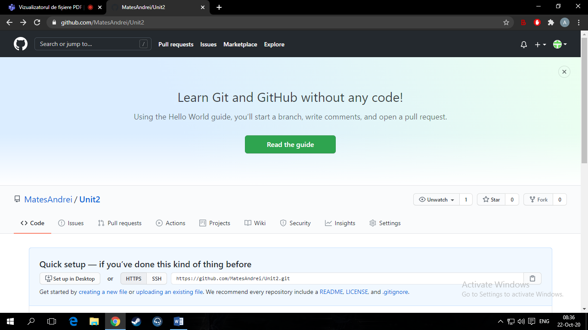

**Link:** **https://github.com/MatesAndrei/Unit2.git**